

**PRACTICAL FILE FOR IT SKILL LAB – 1**

**SESSION- 2022-24**

**SUBJECT CODE – KMBN 151**

**SUBMITTED TO: SUBMITTED BY: ANKUR LOHIYA VISHAL DIWVEDI**

**ROLL NO – ITM MBA 22 498**

**SECTION - L**

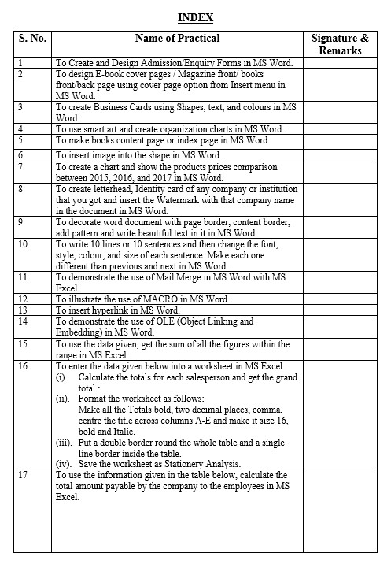

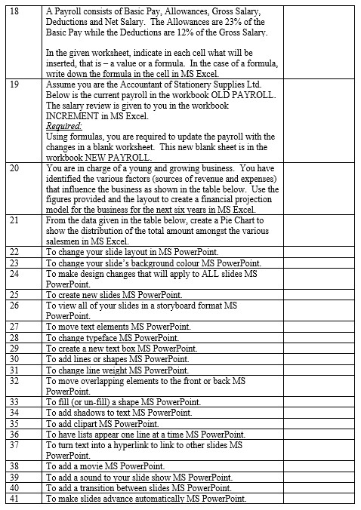

# PRACTICAL:01

Objective: Create and design admission enquiry

Step: 1 open MS Word

Step: 2 insert menu < cover page

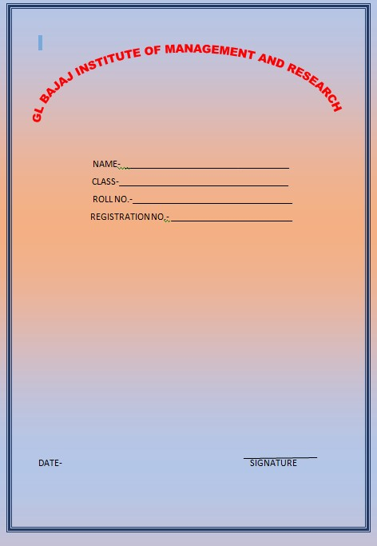

# PRACTICAL:02

Objective: Design E- book cover pages

Step: 1 open MS Word

Step; 2 insert menu > cover page



# PRACTICAL: 03

Objective: Create Business Card Using Shape,Text And Colour

Step: 1 Open MS Word

Step: 2 Click Insert >Select Business Card



# PRACTICAL: 04

Objective: Use Smart Art And Create Organization Charts

Step: 1 open MS Word

Step: 2 Click Insert>Select Organization Chart



# PRACTICAL: 05

**Objective:Make books content page or index page**

**Steps :**

**1: open Ms-Word**

**2: Select Font**



# PRACTICAL: 06

Objective: Create a book index

Step: 1 open MS Word

Step: 2 insert shape > fill shape

Step: 3 Align



# PRACTICAL: 07

Objective: Create a chart and show a product price between 2015,2016 and 2017

Step:1 open MS Word

Step:2 insert menu> chart

Step; 3 fill the date

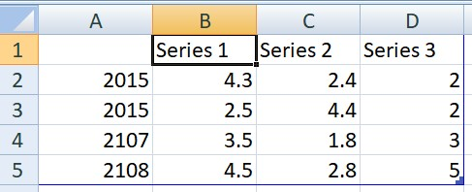

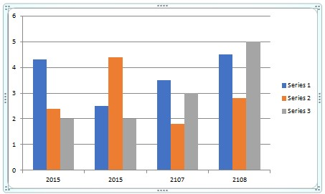

# PRACTICAL: 08

Objective: create letterhead

Step: 1 open MS Word

Step: 2 Insert picture > add watermark



# PRACTICAL:09

Objective: Decorate word document with page border, content border

Step: 1 open MS Word

Step: 2 click insert > select word document



# PRACTICAL:10

Objective: write 10 lines and then change the font , style, color and size

Step: 1 open MS Word

Step: 2 Click Insert>Select 10 Line Or 10 Sentences



# PRACTICAL : 11

Objective: To demonstrate the working of Mail Merge in MS Word from MS Excel.

Steps 1: Write a letter in MS Word with some fields to be customised like Recipient’s Name, Address Contact No. etc (the records which will vary person to person) which is to be sent to multiple contacts.

Step 2: Create the contact information list in MS Excel, so that instead of creating letter separately for each contact we can fetch the contact details from MS Excel automatically.

Step 3: Carefully assign the Header Row in MS Excel, as each Header in MS Excel will replace a placeholder in MS Word document.

Step 4: Click on mailings tab in MS Word.

Step 5: Click on select recipients option and select use an existing list.

Step 6: Browse and select the MS Excel contact list and check on First Row of Data contains Column Headers.

Step 7: Click Ok.

Step 8: Select Edit Recipient List if you need to edit any contact’s record.

Step 9: Select Greeting Line and customize it.

Step 10: Select Insert Merge Field to customize the Recipient Name and click Ok after selecting the fields.

Step 11: To customize Street, Address, City, State and Zip Code select Address Block option and click Ok (use match fields in case of any mismatching records/ missing records).

Step 12: Click Preview Results and correct any mistakes, (changes made will be by default applicable to all records).

Step 13: Click Finish and Merge and select Print or Email activity that is to be performed.

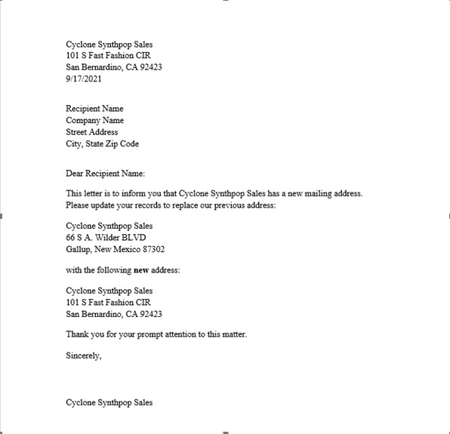

MS Word Document to be Mail Merged

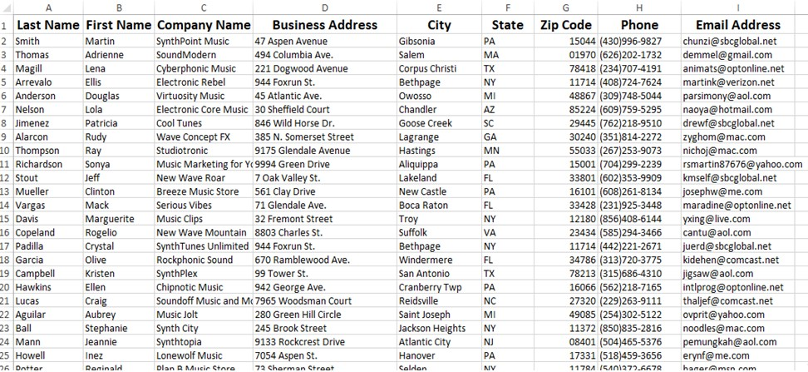

MS Excel Contact List

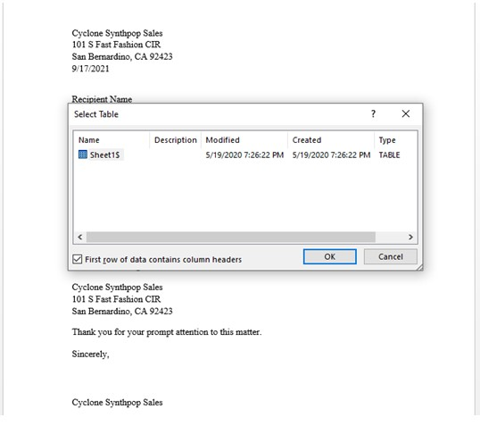

Adding Recipient’s List

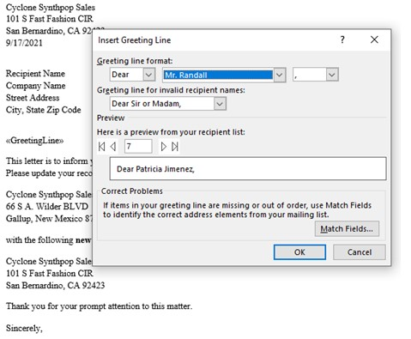

Customize Greeting Line

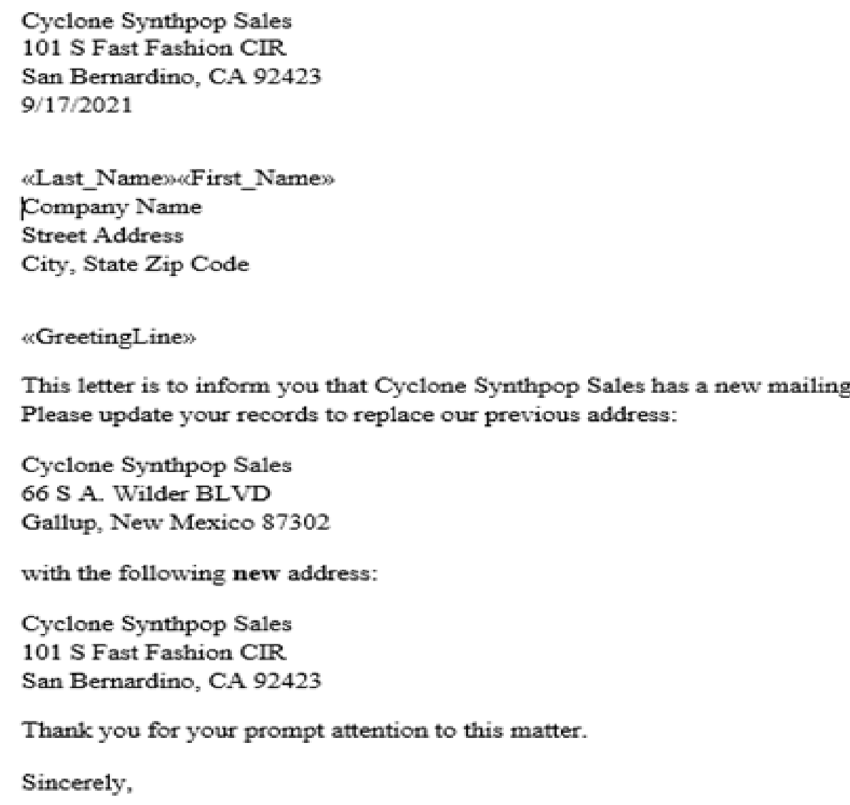

Customize Recipient’s Name in Address

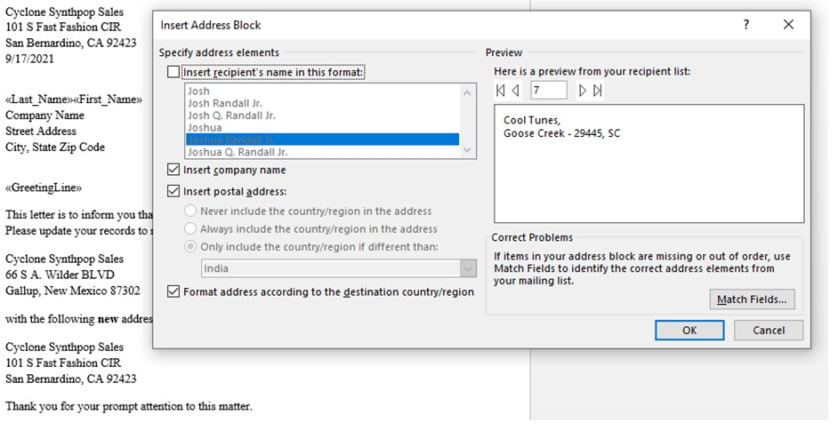

Customize Address Block

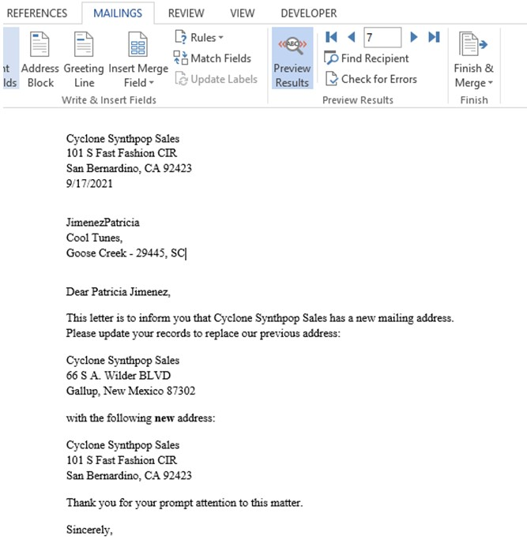

Preview Results

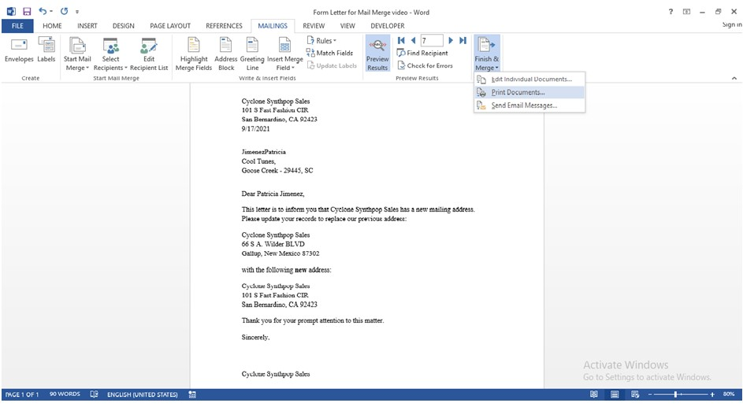

Finish and Merge

# PRACTICAL. 12

Objective: To create and run Macro in MS Word.

Step 1: Open MS Word and Click on View Tab.

Step 2: Select Macro and click on Record Macro option.

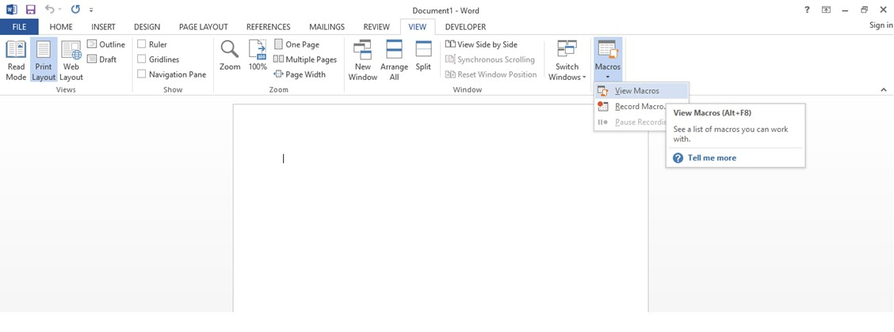

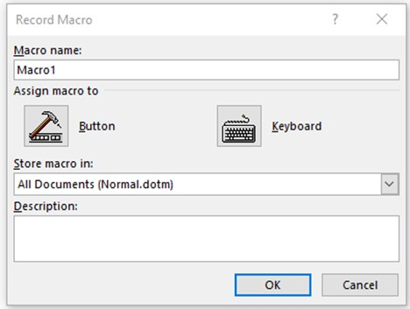

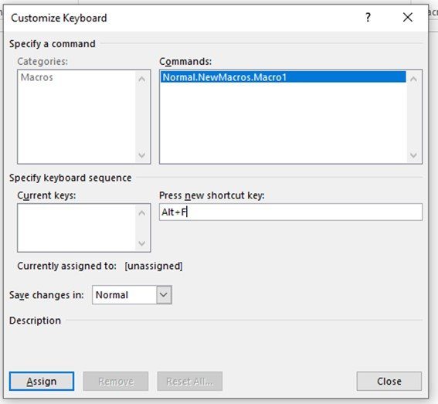

Step 3: Start performing the task you want to record in your Macro, here we are creating the layout of a letter.



Step 4: Select Stop Recording

Step 5: Now to use Macro Click Macro and Select View Macro on a new file.

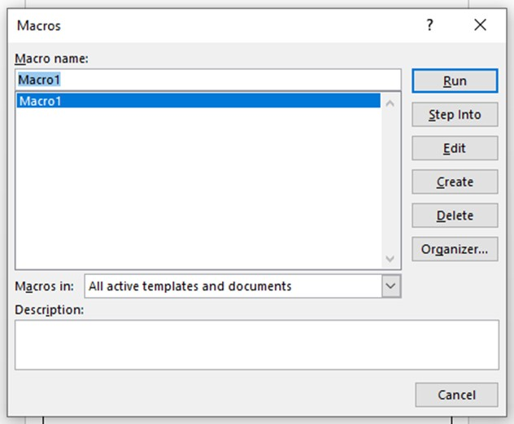

Step 6: Click Run Macro to automatically perform the above task.

# PRACTICAL; 13

Objective: To create a Hyperlink in MS Word.

Step 1: Open MS Word and write any text to be converted to hyperlink.

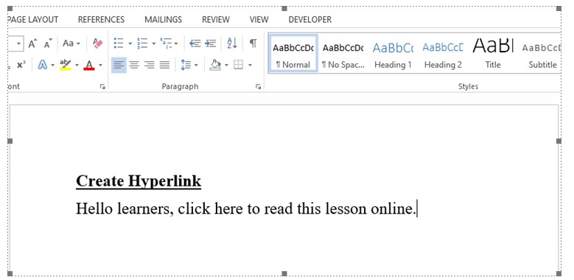

Step 2: Select the text to be converted to a hyperlink.

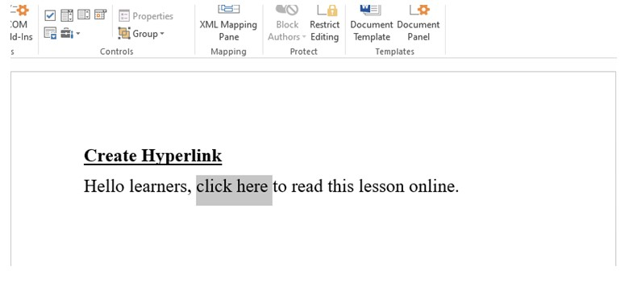

Step 3: Click Insert -> Select Hyperlink -> Paste Web Address in the dialog box and click ok.

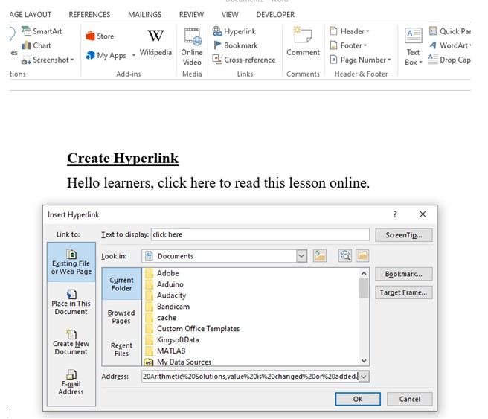

Step 4: Press Ctrl + Click to follow the link.

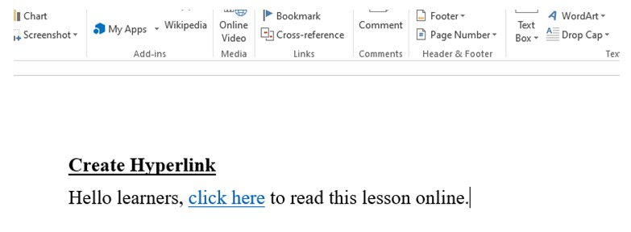

# PRACTICAL - 14

Objective: To use OLE (Object Linking and Embedding) in MS Word.

To Link

Step 1: Open MS Word -> Click Insert -> Select Object.

Step 2: Select Create from File option, and browse for the respective file.

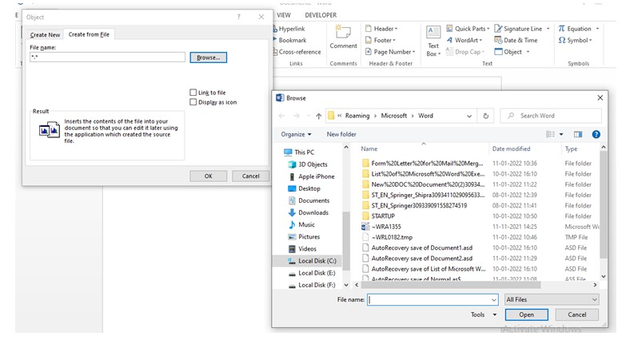

Step 3: Select any file, check on Link to File and click ok.

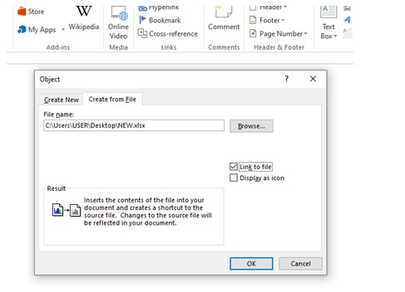

The file will be linked on the MS Word document as below,

Changes made to the source document will be reflected in MS Word (include object again to see changes).

To Embed

Step 1: Open MS Word -> Click Insert -> Select Object.

Step 2: Select Create New and the type of file to be embedded.

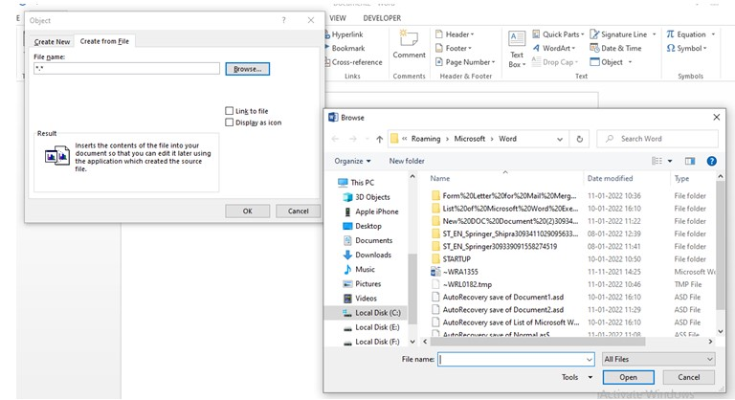

Step 3: Make changes to the file embedded as per requirement.

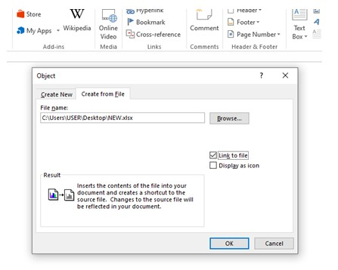

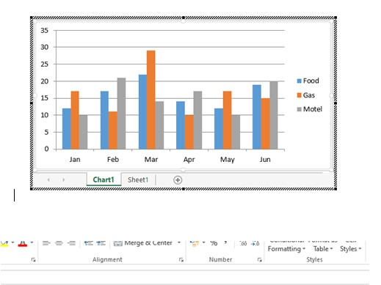

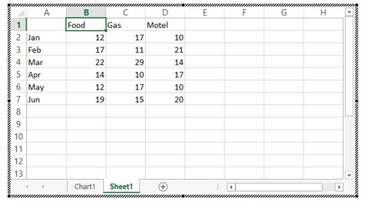

# PRACTICAL:15

Objective: To Find Out The Sum

Formula=Sum(From Column Number : To Column Number )

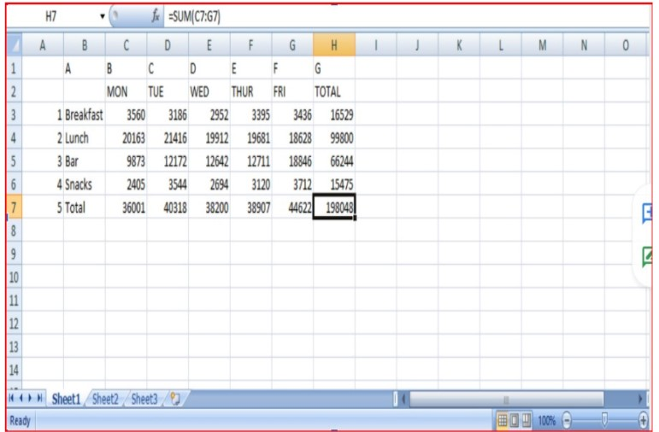

## PRACTICAL:16

Objective:

(i). Calculate the totals for each salesperson and get the grand total.:

(ii). Format the worksheet as follows: Make all the Totals bold, two decimal places, comma, center the title across columns A-E and make it size 16, bold and Italic.

(iii). Put a double border round the whole table and a single line border inside the table.

(iv). Save the worksheet as Stationery Analysis.

Formula=Sum(Form Column : To column)

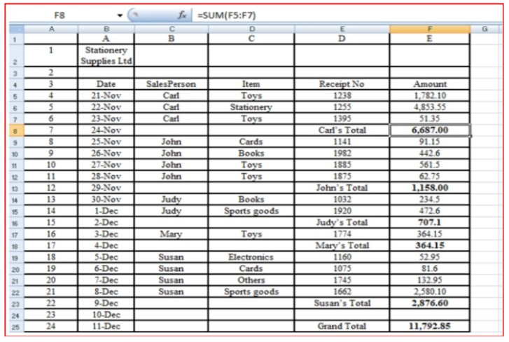

## PRACTICAL:17

Objective: Calculate the total amount payable by the company to the employees.

Formula=Column Number*Column Number

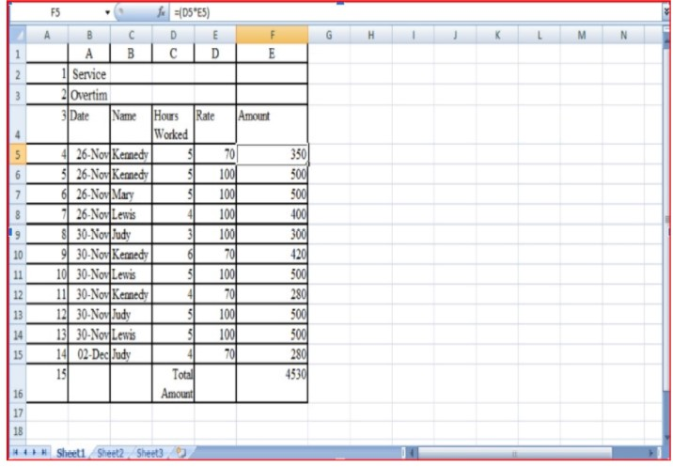

## PRACTICAL:18

Objective: A Payroll consists of Basic Pay, Allowances, Gross Salary, Deductions and Net Salary. The Allowances are 23% of the Basic Pay while the Deductions are 12% of the Gross Salary.

In the given worksheet, indicate in each cell what will be inserted, that is – a value or a formula. In the case of a formula, write down the formula in the cell.

Formula:(1):=Sum(Form column : To Column)

(2):=Form Column - To column

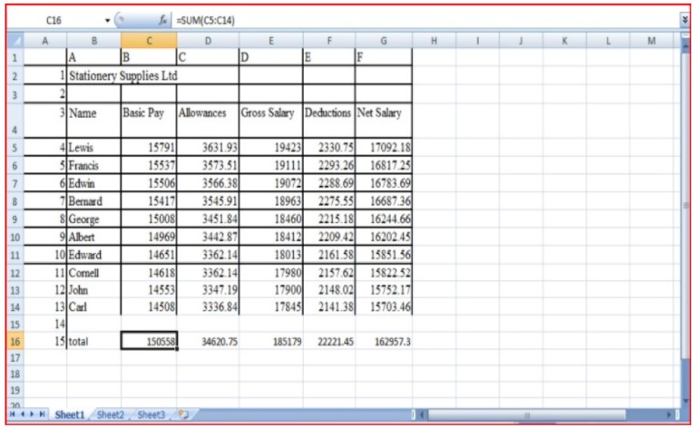

## PRACTICAL:19

Objective: Using formulas, you are required to update the payroll with the changes in a

blank worksheet. This new blank sheet is in the workbook NEW PAYROLL.

Formula:(1):=Sum (From Column : To Column) (2):=From Column - To Column

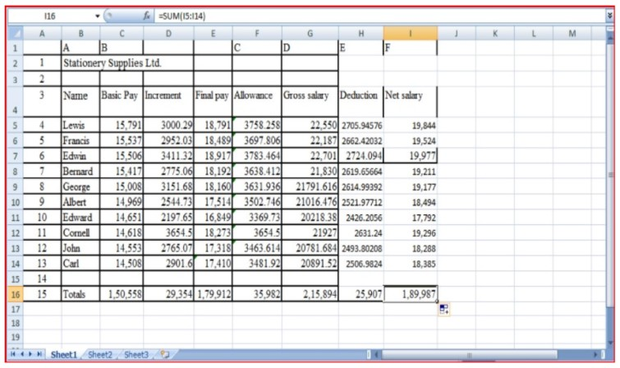

## PRACTICAL:20

Objective: You have identified the various factors (sources of revenue and expenses) that influence the business as shown in the table below. Use the figures provided and the layout to create a financial projection model for the business for the next six years.

The parameters are given on Sheet 2.

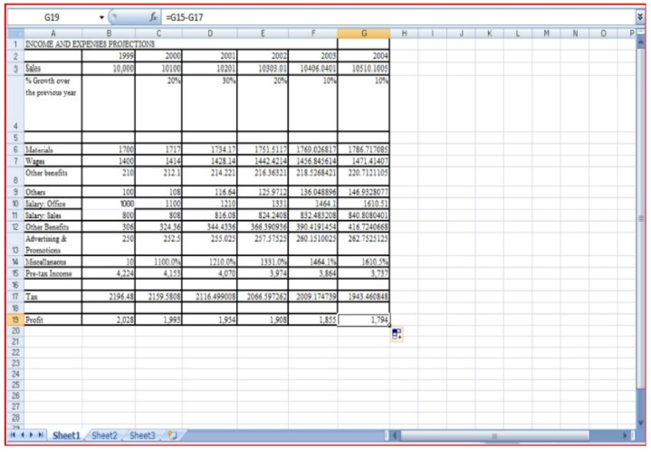

## PRACTICAL:21

Objective: From the data given in the table below, create a Pie Chart to show the

distribution of the total amount amongst the various salesmen.

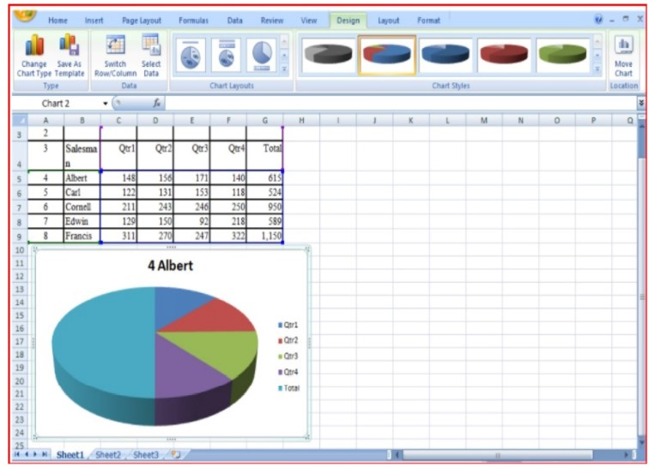

## PRACTICAL:22

Objective: To Change Your Slide Layout

Steps:

Open MS Powerpoint

Click On Design ->Select Any Layout

Go To Home Tab ->Select Layout And Choose Any Desired Layout.

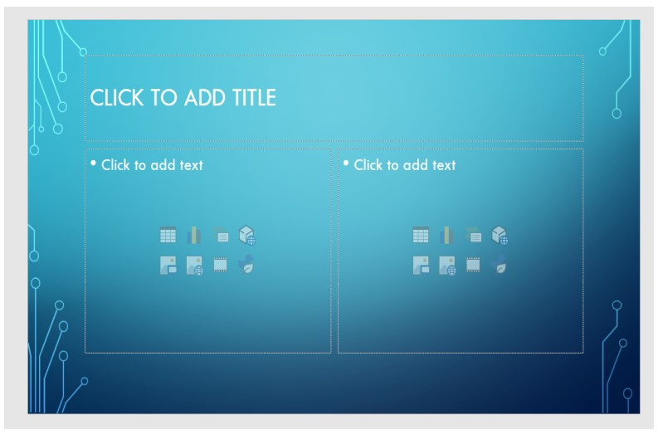

## PRACTICAL:23

Objective: To Change Your Slide’s Background Colour

Steps:

Open MS Powerpoint

Click On Design->Select Format Background

Choose Solid Fill And Select Any Desired Colour.

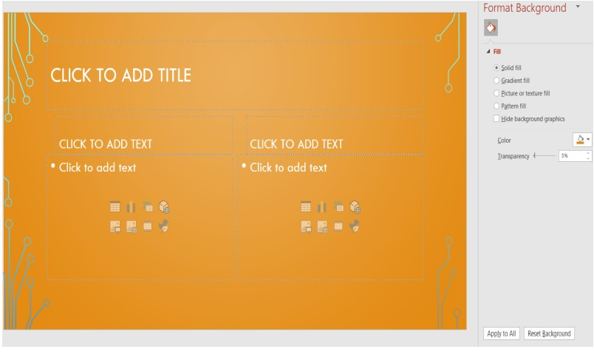

## PRACTICAL:24

Objective: To Make Design Change That Will Apply To All Slides

Steps:

Open MS Powerpoint

Click On Design->Select Any Layout

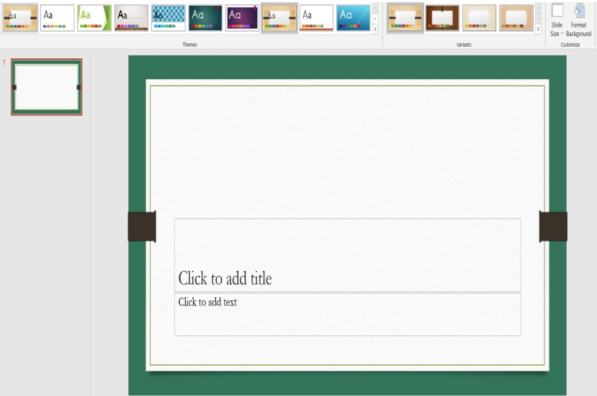

## PRACTICAL:25

Objective: To Create New Slides

Steps:

Open MS Powerpoint

Click On Home Tab->Select New Slide Option.

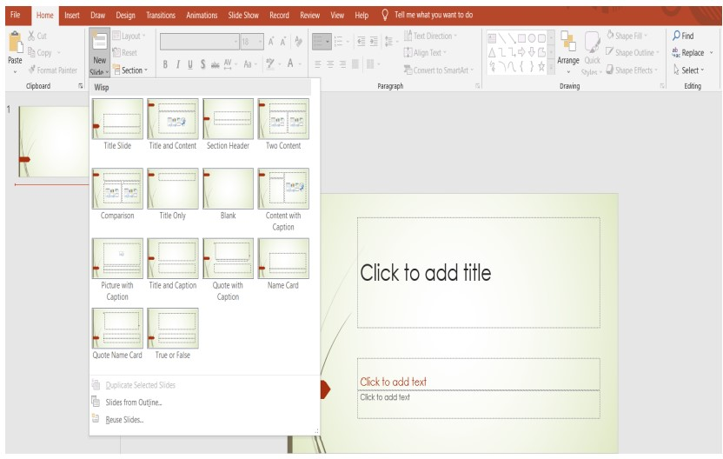

## PRACTICAL:26

Objective: To View All Of Your In A Storyboard Format.

Step:(1)Open MS Powerpoint

(2)Click On View->Select Slide Sorter

(3)Click On View->Select Normal To Return To Design View

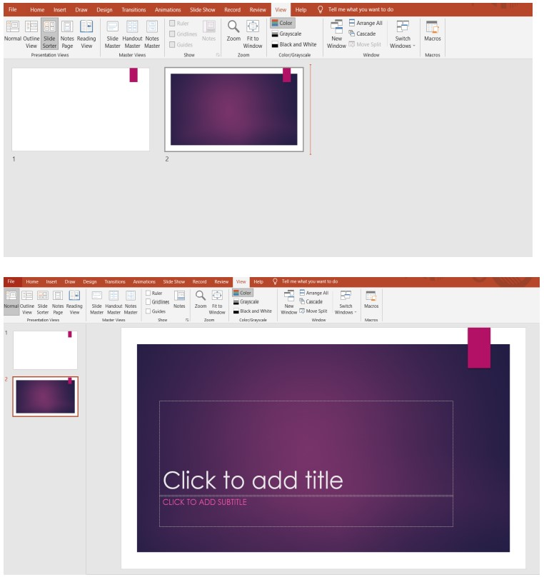

.

## PRACTICAL:27

Objective: To Move Text Elements

Steps:

(1)Open MS Powerpoint

(2)Type Any Text

(3)Select The Word(s),Then Click And Drag The Box To A New Location.

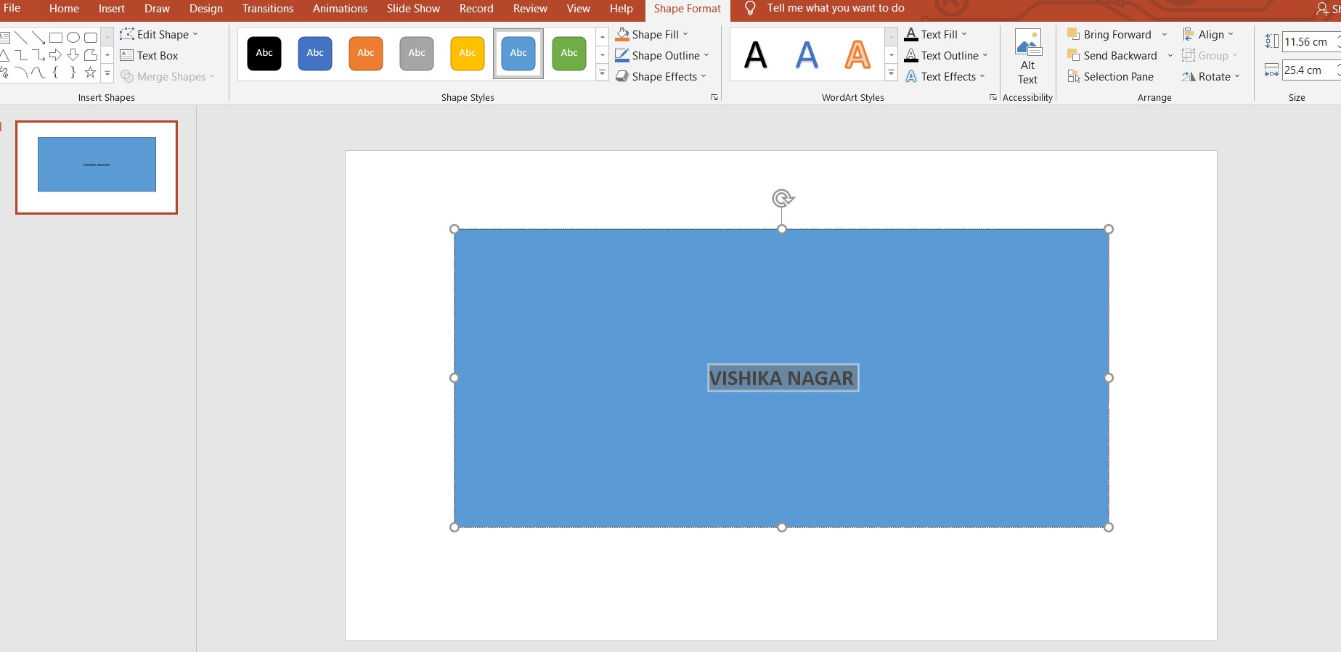

## PRACTICAL:28

Objective: To Change Typeface

Step:(1)Open MS Powerpoint

(2)Select The Word(s),Then Use The Format Tab/Text Tools To Change formatting.

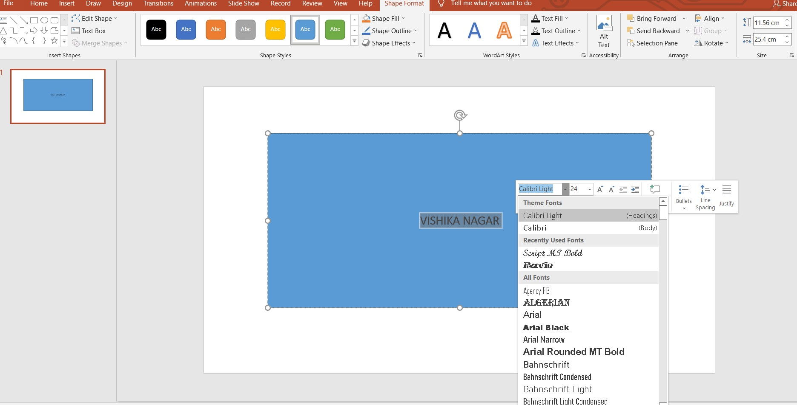

## PRACTICAL:29

Objective: To Create A New Text Box

Step:(1)Open MS Powerpoint

(2)Click Insert ->Select Text Box

(3)Click And Drags To Draw The Text Box And Type Inside To Text Box To Add Text.

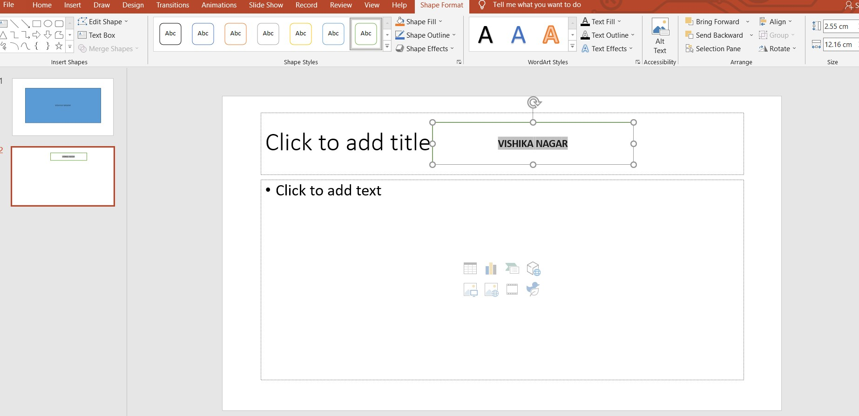

## PRACTICAL:30

Objective: To Add Line Or Shape

Step:(1)Open MS Powerpoint

(2)Click Insert->Select Shape.

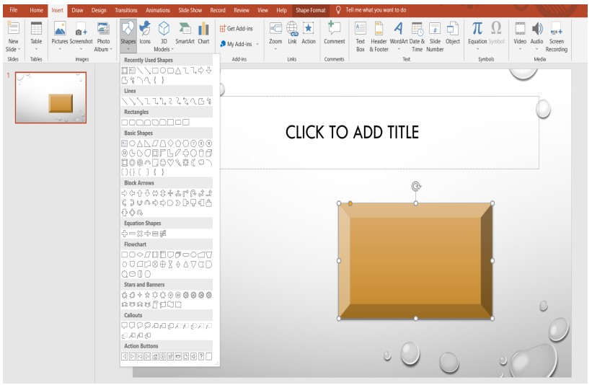

## PRACTICAL:31

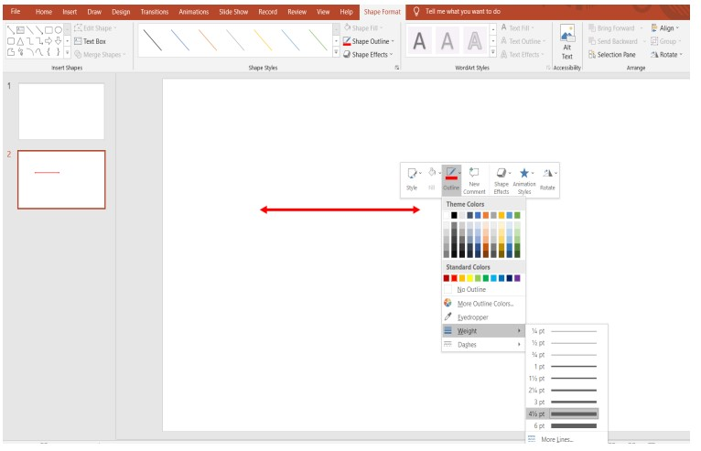Objective: To Change Line Weight

Step:(1)Open MS Powerpoint

(2)Click Insert->Select Shapes->Choose Line

(3)Click Format Tab->Select Shape Online->Select Weight And Choose Any Desired Weight.

## PRACTICAL:32

Objective: Move Overlapping Elements To The Front And Back.

Step:(1)Open MS Powerpoint

(2)Draw/Insert The Overlapping Elements/Picture

(3)Choose Any One Element By Clicking On It.

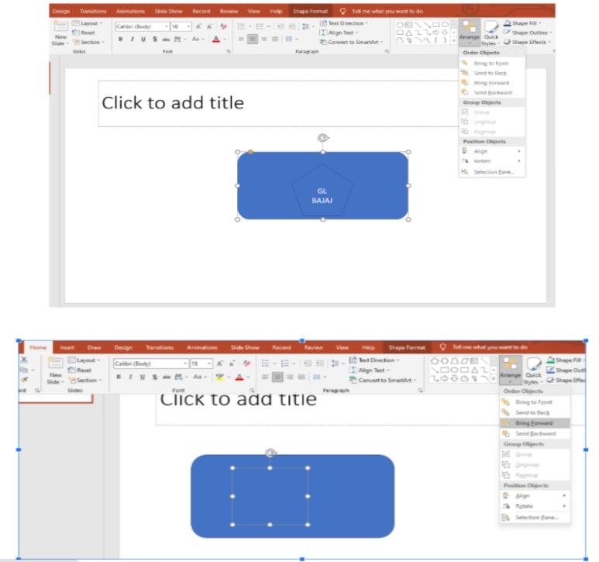(4)Click On Format Tab/Select Send Backward/Bring Forward To Move The Element

## PRACTICAL:33

Objective: To Fill (Or Unfill) A Shape

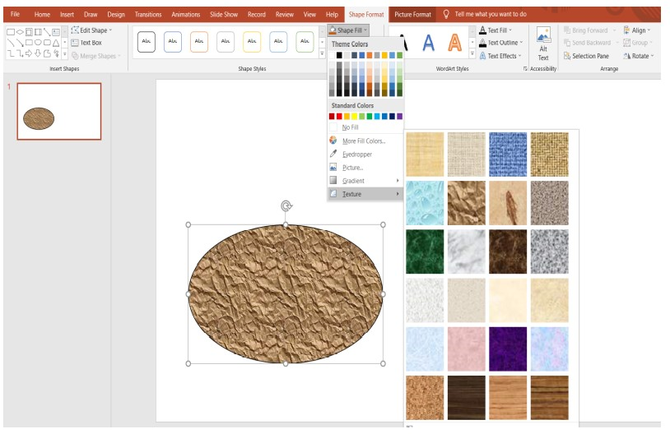Steps:(1)Open MS Powerpoint

(2)Click Insert >Select Shape>Click And Drag To Draw The Shape.

(3)Click Format Tab>Select Shape Fill>Choose Color/Picture/Gradient/Texture To Be Filled.

## PRACTICAL:34

Objective: To Add Shadow To Text

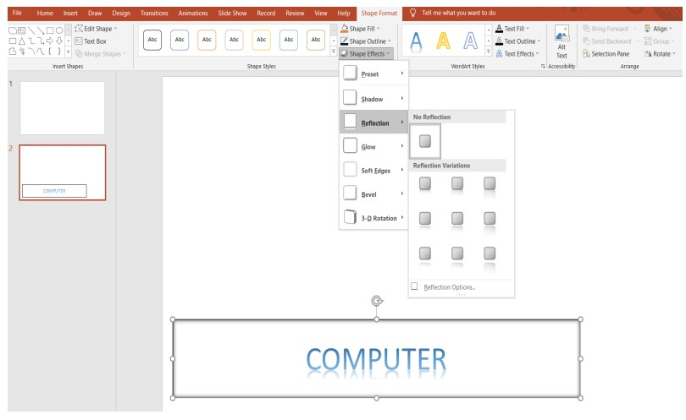Step:(1)Open MS Powerpoint

(2)Type Any Text

(3)Select The Text And Click Format Tab

(4)Click Shape Effects>Select Shadows>Choose Any Desired Style Of Shadow.

## PRACTICAL:35

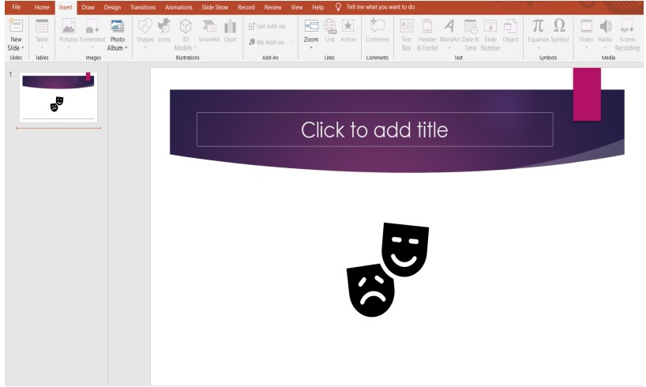Objective: To Add Clipart.

Step:(1)Open MS Powerpoint

(2)Click Insert>Select Icons>Choose Any Desired Icon.

## PRACTICAL:36

Objective: To Have Lists Appear One Line At A Time.

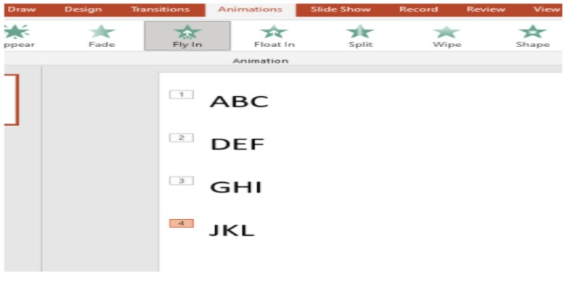Step:(1)Open MS Powerpoint

(2)Type Any Text

(3)Click Animations Tab>Select Text>(lines)One By One And Choose Desired Animation.

## PRACTICAL:37

Objective: To Turn Text Into A Hyperlink To Link To Other Slides.

Steps:(1)Open MS Powerpoint

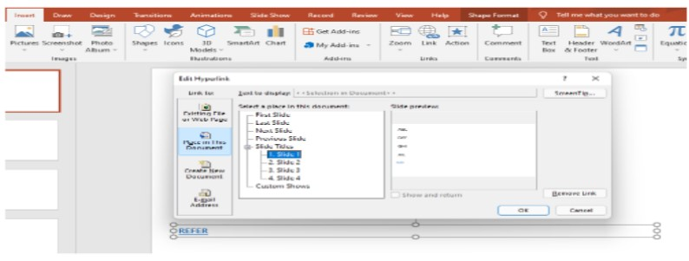(2)Type Any Text To BE Converted To Hyperlink.

(3)Click Insert>Select Link/Hyperlink (4)Select “Place In This Documents”Option.

(5)Choose The Slide You Wish To Link.

(6)Click On The Text Using Ctrl+Click To Land On The Mapped Slide.

## PRACTICAL:38

Objective: To Add A Movie.

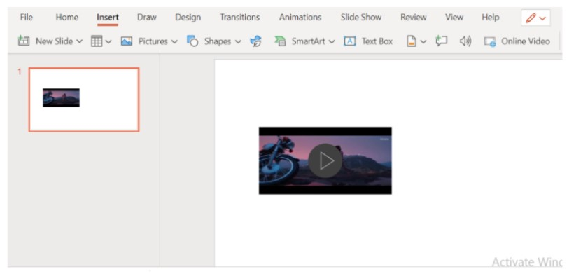Steps:(1)Open MS Powerpoin.t

(2)Click Insert->Select Video.

(3)Choose Video Either From The System Or Online.

## PRACTICAL:39

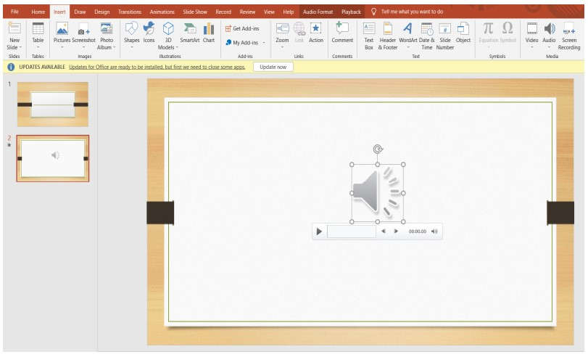Objective: To Add A Sound To Your Slide Show.

Step: Open MS Powerpoint Click Insert Tab->Choose Audio->Choose Either Sound From This PC Or Record Sound.

## PRACTICAL:40

Objective: To Add A Transition Between Slides

Step: Open MS Powerpoint

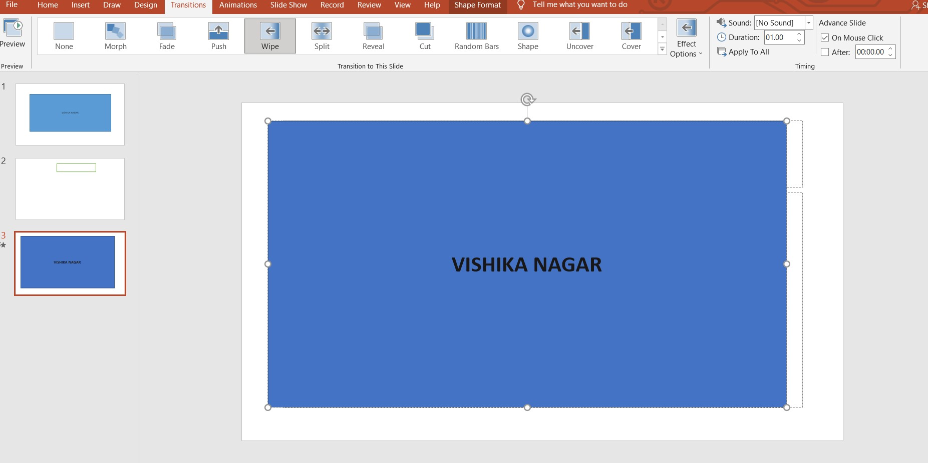Click Transition Tab>Select Any Desired Transition

## PRACTICAL:41

Objective: To Make Slides Advance Automatically

Steps:Open MS Powerpoint Click Slideshow >Select Rehearse Timings. Save Timings As Per Your Wish And Next Time SlideShow Will Run Automatically As Per Recorded Time.

